Austin Johns

CST-217

William Hurst

Index View and Creation

Here, I joined the discount possible with the email address ID. If a company wanted to see how many ways they could mix up a special offer with the number of customers they have in a system, they could refer to this table.

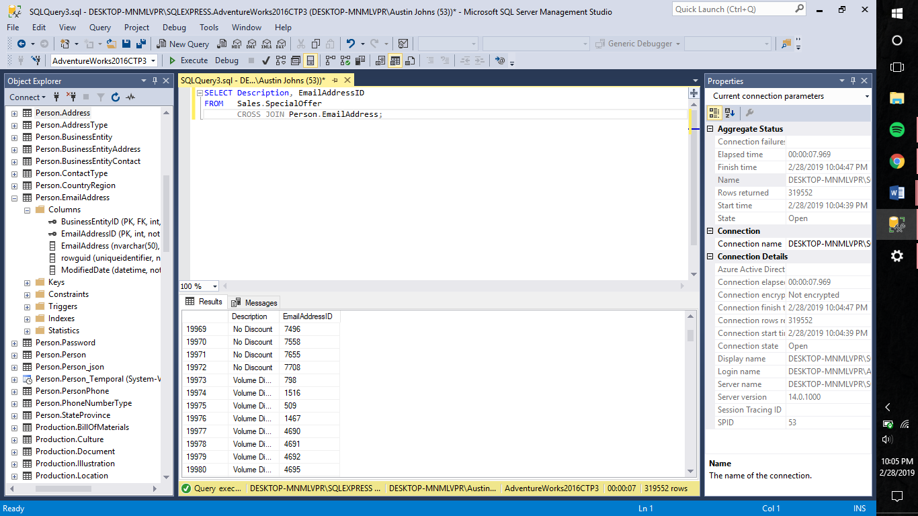

SELECT Description, EmailAddressID

FROM Sales.SpecialOffer

CROSS JOIN Person.EmailAddress;